

Nigel 4WD4WS – Assembly Guide

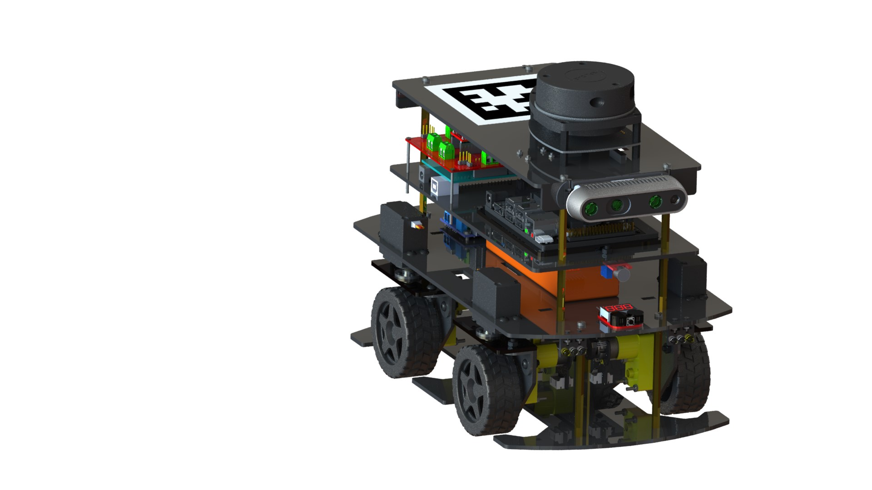

|  |  |
| --- | --- |
| **Drafted By:** | Rohit Ravikumar |
| **Finalized By:** | Tanmay Samak |
| **Version No:** | 1.0.0 |

**Table of Contents**

**1. Introduction** 1

**2. Assembly Guide** 2

**2.1 Wheel-End Sub-Assembly** 3

**2.2 Platform 2 Assembly** 8

**2.3 Platform 3 Assembly** 14

**2.4 Platform 4 Assembly** 19

**2.5 Overall Assembly** 24

**3. Actuation Redundancy** 29

**4. Modularity and Reconfigurability** 30

**5. Supplemental Material** 31

# **1. Introduction**

The designed vehicle, Nigel, comprises of four modular platforms, each housing distinct components and subsystems of the vehicle. The individual platforms are fabricated by laser cutting 3 mm thick acrylic sheets, which are stacked at the designed offsets employing brass spacers of appropriate length.

The first (i.e., bottom-most) platform acts as a scrub-guard and covers the wheel-end sub-assemblies. The second platform hosts 4 steering servo actuators coupled with the respective wheel-end sub-assemblies and hosts power electronics components including a lithium polymer (LiPo) battery, master switch, buck converter, and LiPo voltage checker. It also mounts the front and rear lighting units. The DC geared motors driving each of the 4 wheels are fastened to their respective acrylic mounts as a part of each wheel sub-assembly. The third platform accommodates an onboard computer, along with a custom auxiliary board and also hosts a microphone. The auxiliary board routes connections to the low-level microcontroller unit as well as the motor drivers, and also takes care of power distribution. It also hosts a passive buzzer and a 9-axis IMU. Finally, the fourth platform mounts RGB/RGB-D/stereo cameras and a planar LIDAR unit. It also has vacant space to paste an AprilTag marker to uniquely identify the vehicle. The figure below illustrates various components and sub-systems of the vehicle.

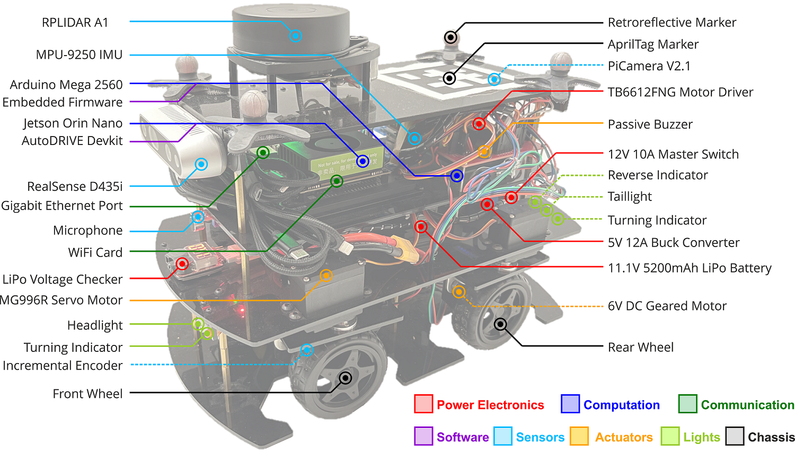

# **2. Assembly Guide**

The entire assembly process can be divided platform-wise. The individual platforms can be assembled as sub-assemblies and then stacked using standoffs to complete the overall assembly.

This manual goes through the entire assembly process in this fashion, with overall steps and detailed instructions on how to assemble each platform.

Detailed bill of materials (BOM) can be found [here](https://github.com/Tinker-Twins/AutoDRIVE/blob/AutoDRIVE-Testbed/Documents/BOM.xlsx).

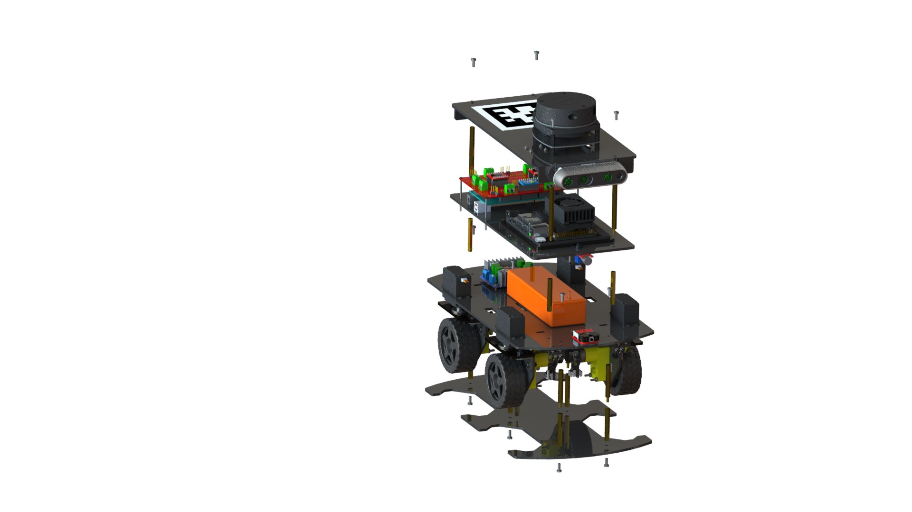

**PLATFORM 4**

**PLATFORM 2**

**PLATFORM 1**

**PLATFORM 3**

## **2.1 Wheel-End Sub-Assembly**

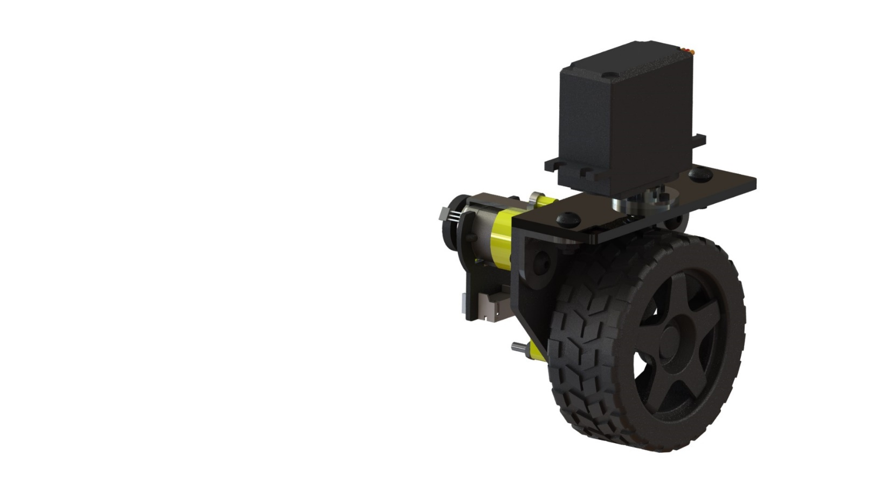

**Components:**

|  |  |  |  |
| --- | --- | --- | --- |
|   **MG996R Servo (x1)** |   **Motor with Encoder (x1)** |   **Drive Motor Mount (x1)** |   **Steering Servo Mount (x1)** |
|   **L-Bracket (x2)** |   **MG996R Servo Horn (x1)** |   **Wheel (x1)** |   **M4 x 10 Bolt (x4)** |

|  |  |  |  |
| --- | --- | --- | --- |
|   **M2.5 x 25 Bolt (x2)** |   **M3 x 6 Bolt (x5)** |   **M4 Nut (x4)** |   **M2.5 Nut (x2)** |

***Note:*** *The above quantities are for a single wheel-end sub-assembly. Four such sub-assemblies are required.*

**Overall Steps:**

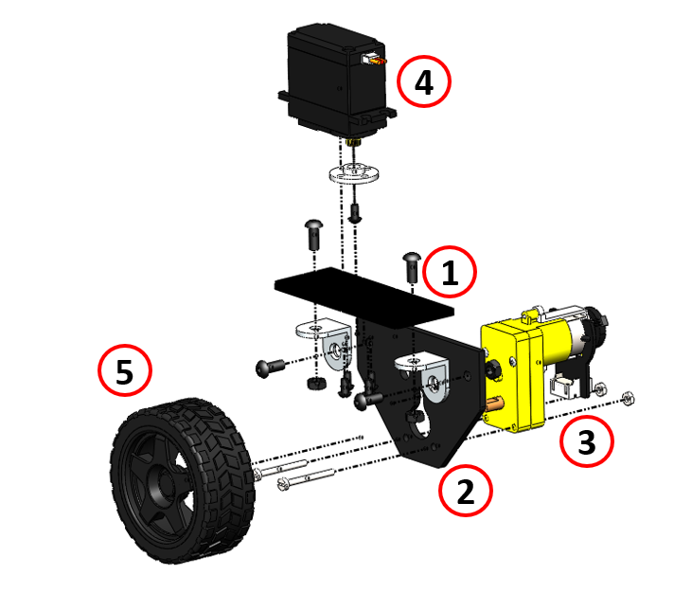

**Detailed Steps:**

1. Assembly of the L-brackets with the steering servo mount.

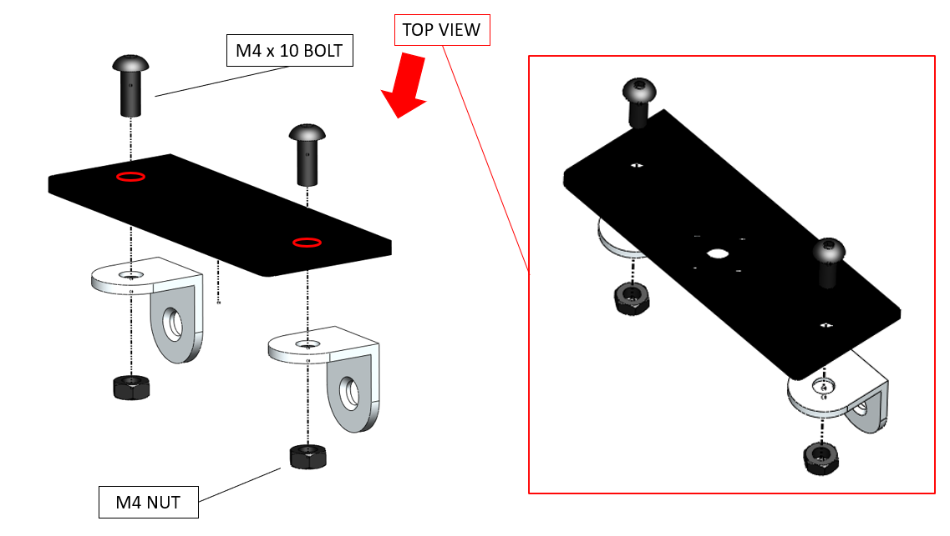

1. Assembly of the drive motor mount with the L-brackets.

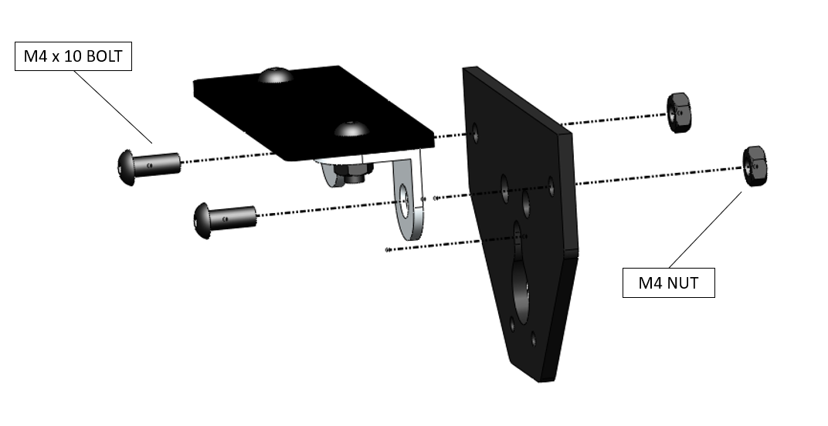

1. Assembly of the TT motor onto the drive motor mount.

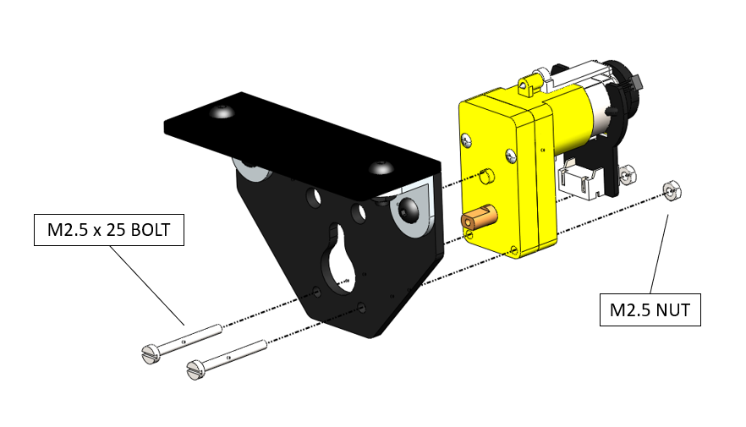

***Hint:*** *The nuts used to fasten the drive motors may come loose over time due to vibrations. This can be avoided by using locknuts, or by twisting two nuts into each other to provide a frictional lock, or by applying glue to the nuts while fastening them.*

1. Assembly of the servo horn onto the servo motor.

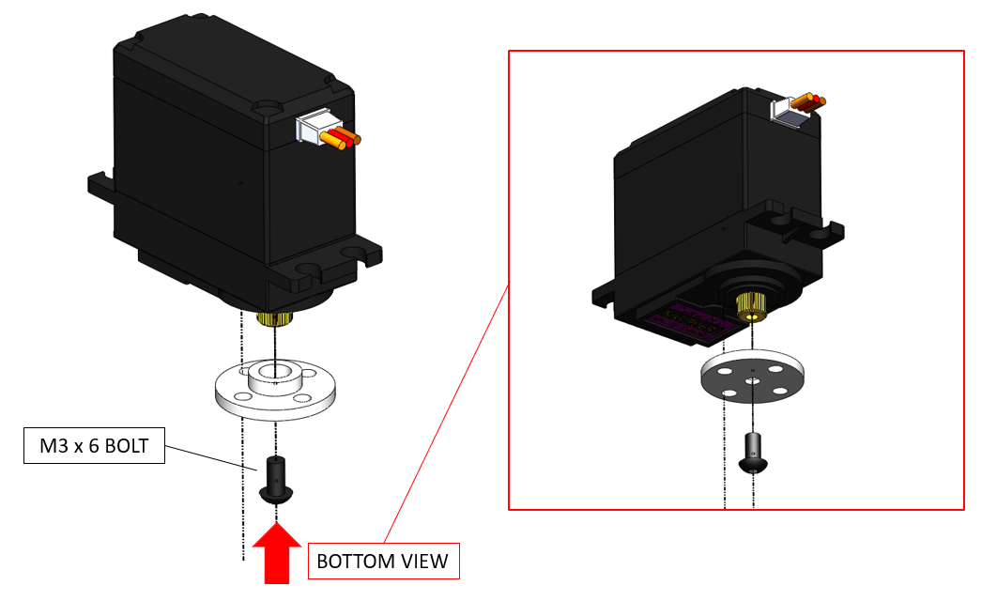

1. Assembly of the steering servo onto the steering servo mount.

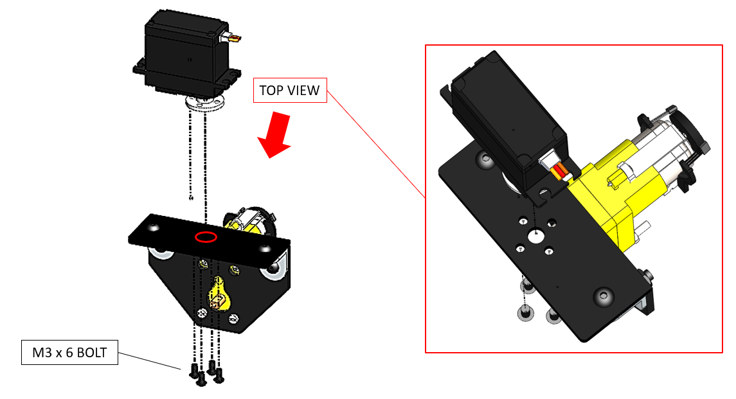

***Note:*** *Make sure to zero-steer the servo to 90 $°$ before attaching the servo horn.*

1. Assembly of the wheel onto the drive motor shaft.

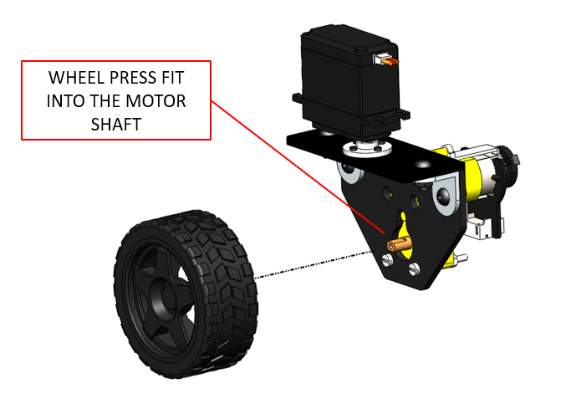

## **2.2 Platform 2 Assembly**

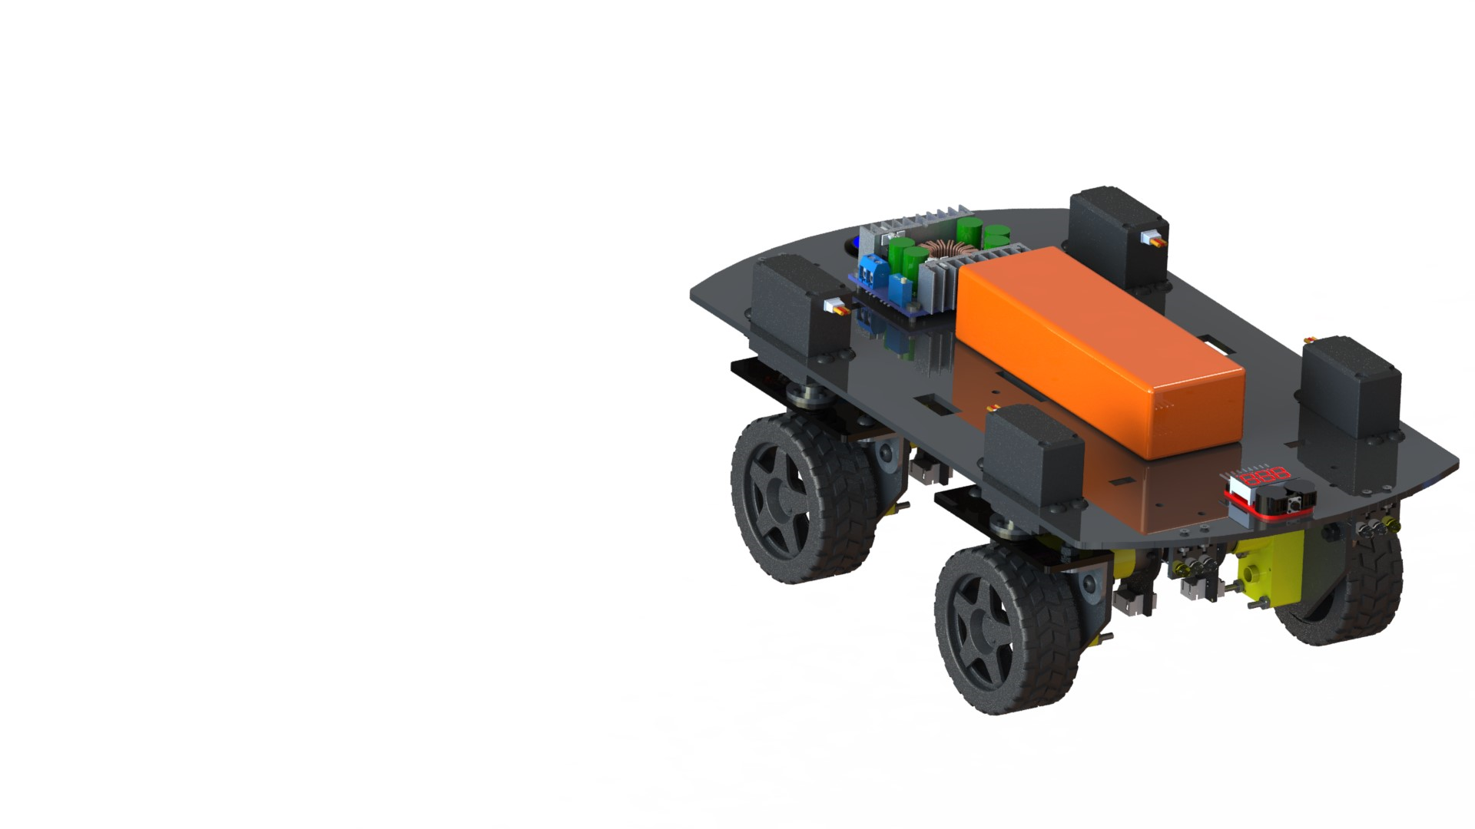

**Components:**

|  |  |  |  |
| --- | --- | --- | --- |
|   **Buck Converter (x1)** |   **LiPo Voltage Checker (x1)** |   **Push Button (x1)** |   **Amber LED (x4)** |
|   **Red LED (x2)** |   **White LED (x6)** |   **11.1V LiPo Battery (x1)** |   **LED Mount (x4)** |
|   **Platform 2 (x1)** |   **Push Button Nut (x1)** |   **M2 x 10 Bolt (x8)** |   **M4 x 10 Bolt (x16)** |
|   **M3 x 14 Bolt (x4)** |   **M4 Nut (x16)** |   **M3 Nut (x4)** |   **M2 Nut (x8)** |
|   **Wheel-End Sub-Assembly (x4)** | |  |  |

**Overall Steps:**

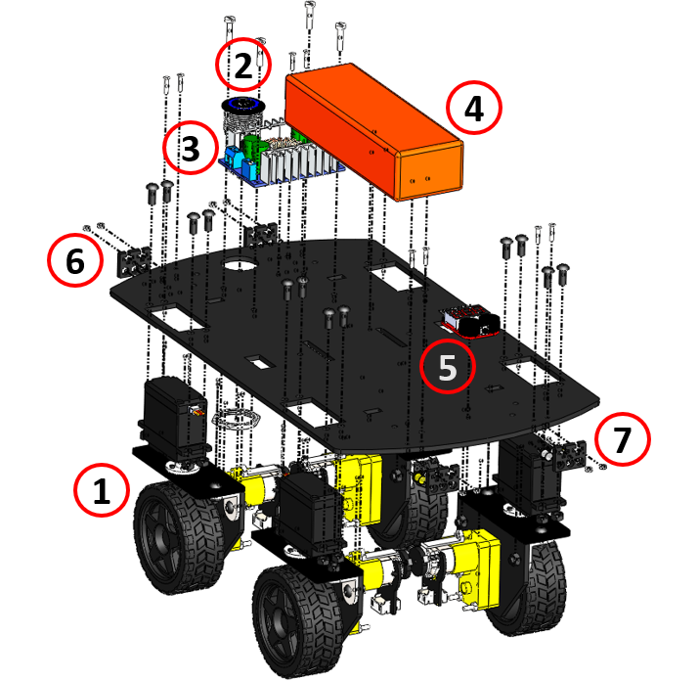

**Detailed Steps:**

1. Assembly of the wheel-end sub-assembly onto the platform.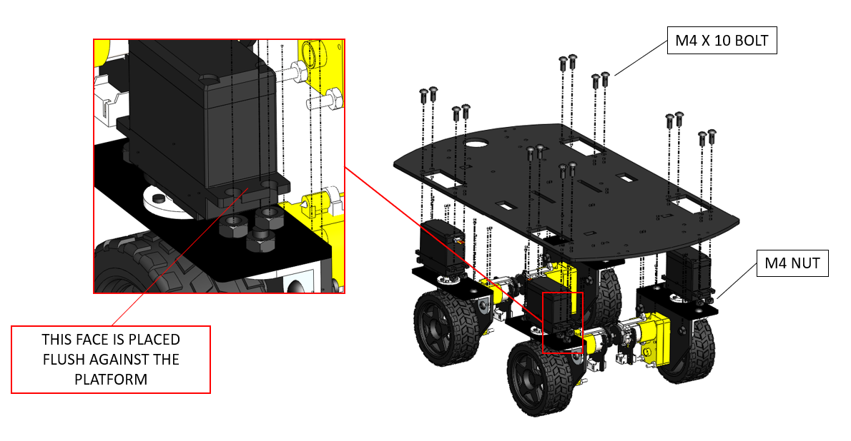
2. Assembly of the master switch onto the platform.

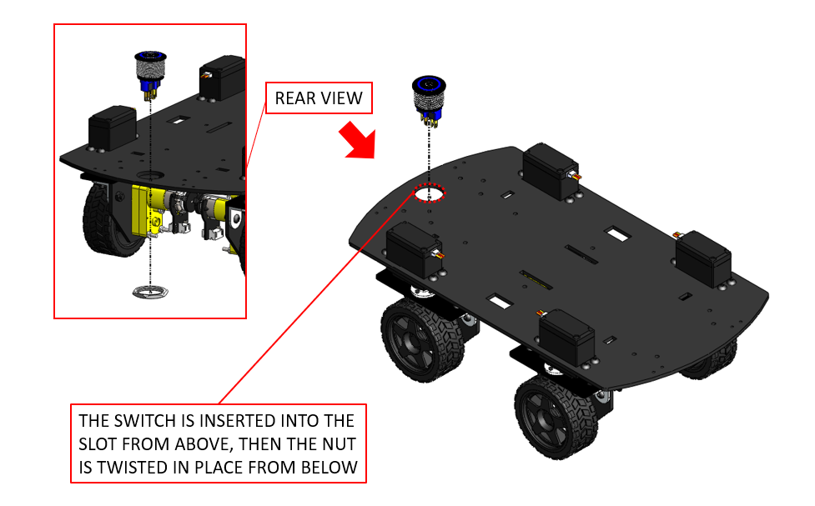

1. Assembly of the buck converter onto the platform.

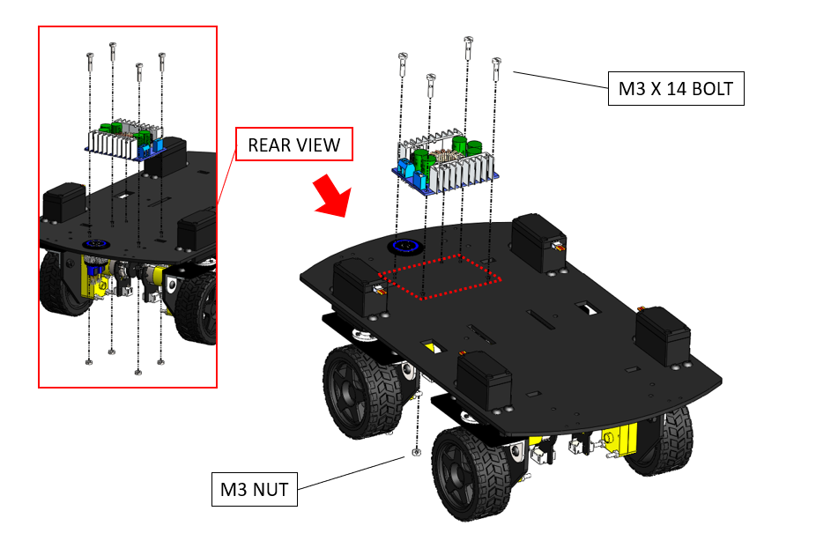

***Note:*** *Make sure to tune the output voltage of the buck converter to 5.00 V.*

1. Securing the LiPo battery onto the platform.

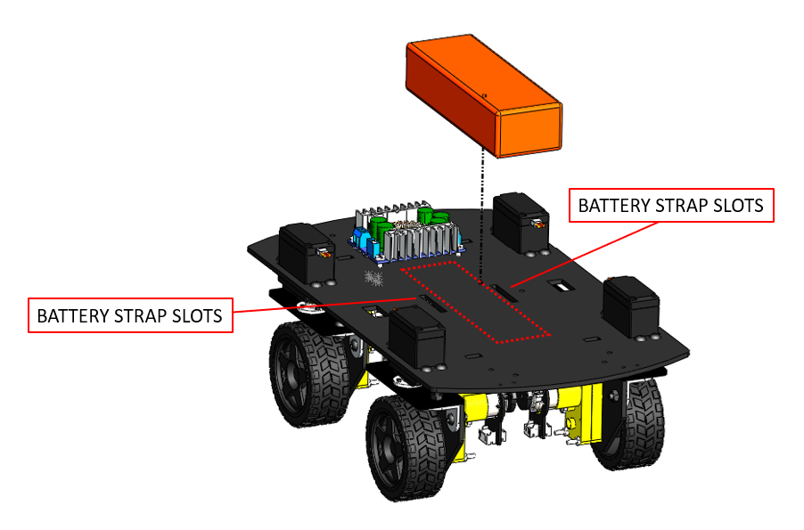

***Note:*** *LiPo batteries are a safety hazard. Please refer to* [*this guide*](https://dronebotworkshop.com/lipo-safety/) *to know more about LiPo safety.*

1. Assembly of the voltage checker module onto the platform.

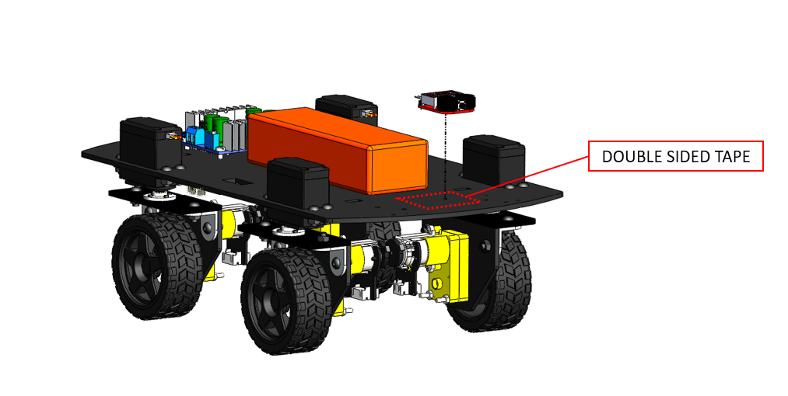

***Hint:*** *You may use hot glue or double-sided tape to secure the voltage checker module in place.*

1. Fitment and sub-assembly of the headlights.

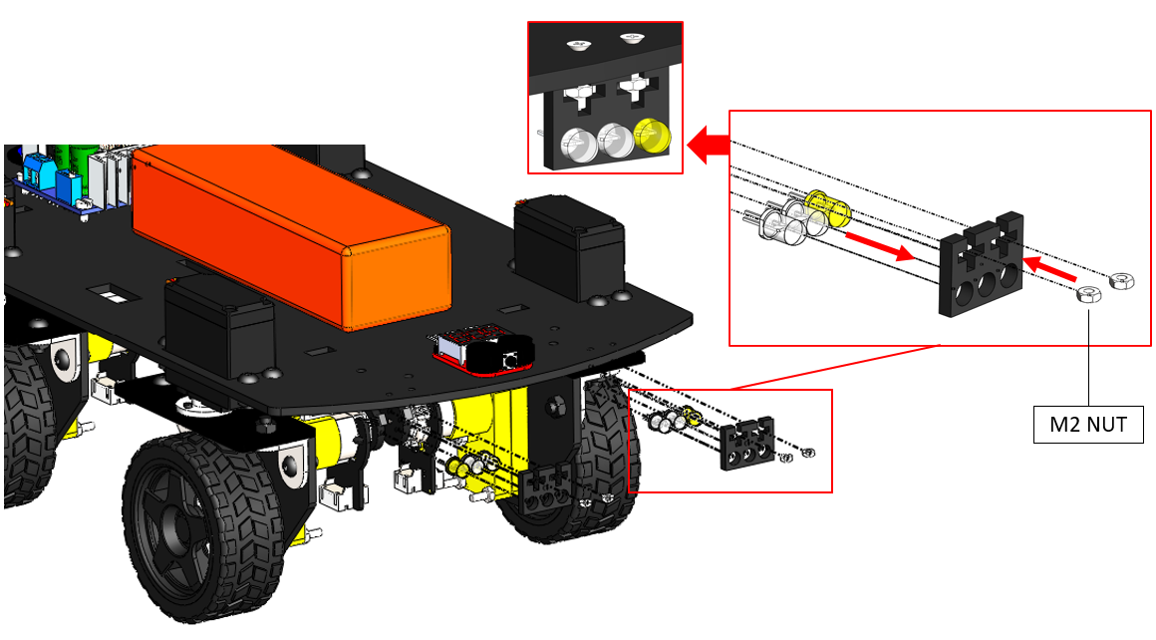

1. Fitment and sub-assembly of the taillights.

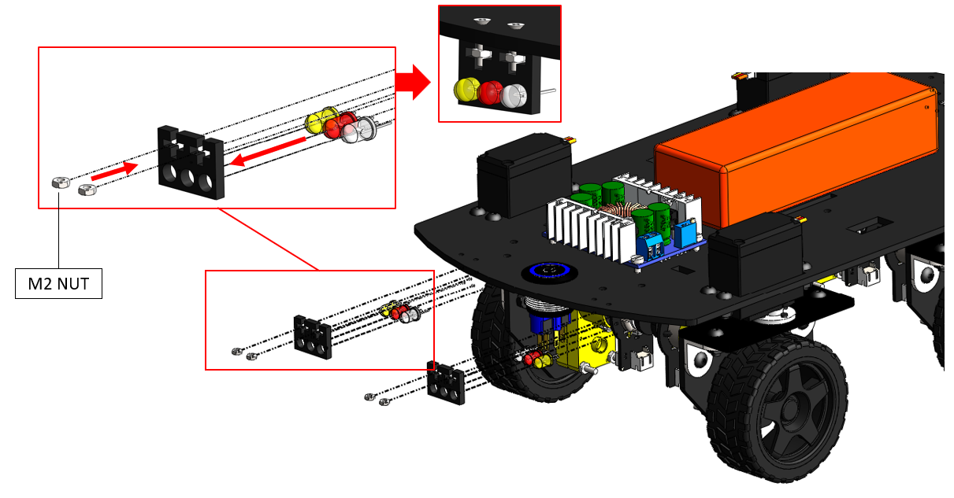

***Hint:*** *Although the LED mounts are designed to friction-fit 5 mm LEDs, the fit might be loose in some cases due to manufacturing errors. In such a case, hot glue can be added to secure the LEDs in place.*

1. Assembly of the headlights and taillights onto the platform.

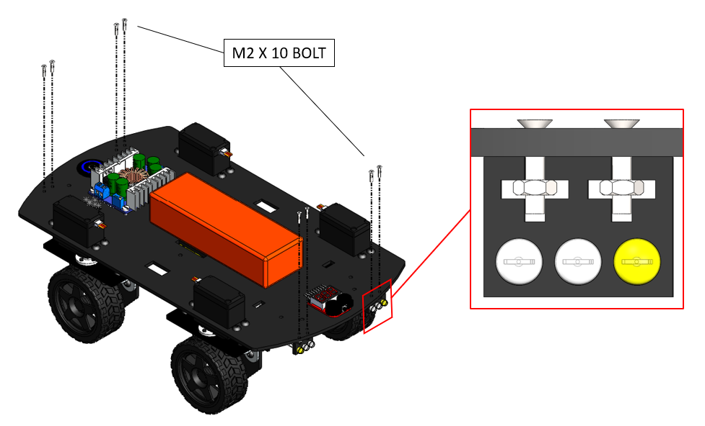

## **2.3 Platform 3 Assembly**

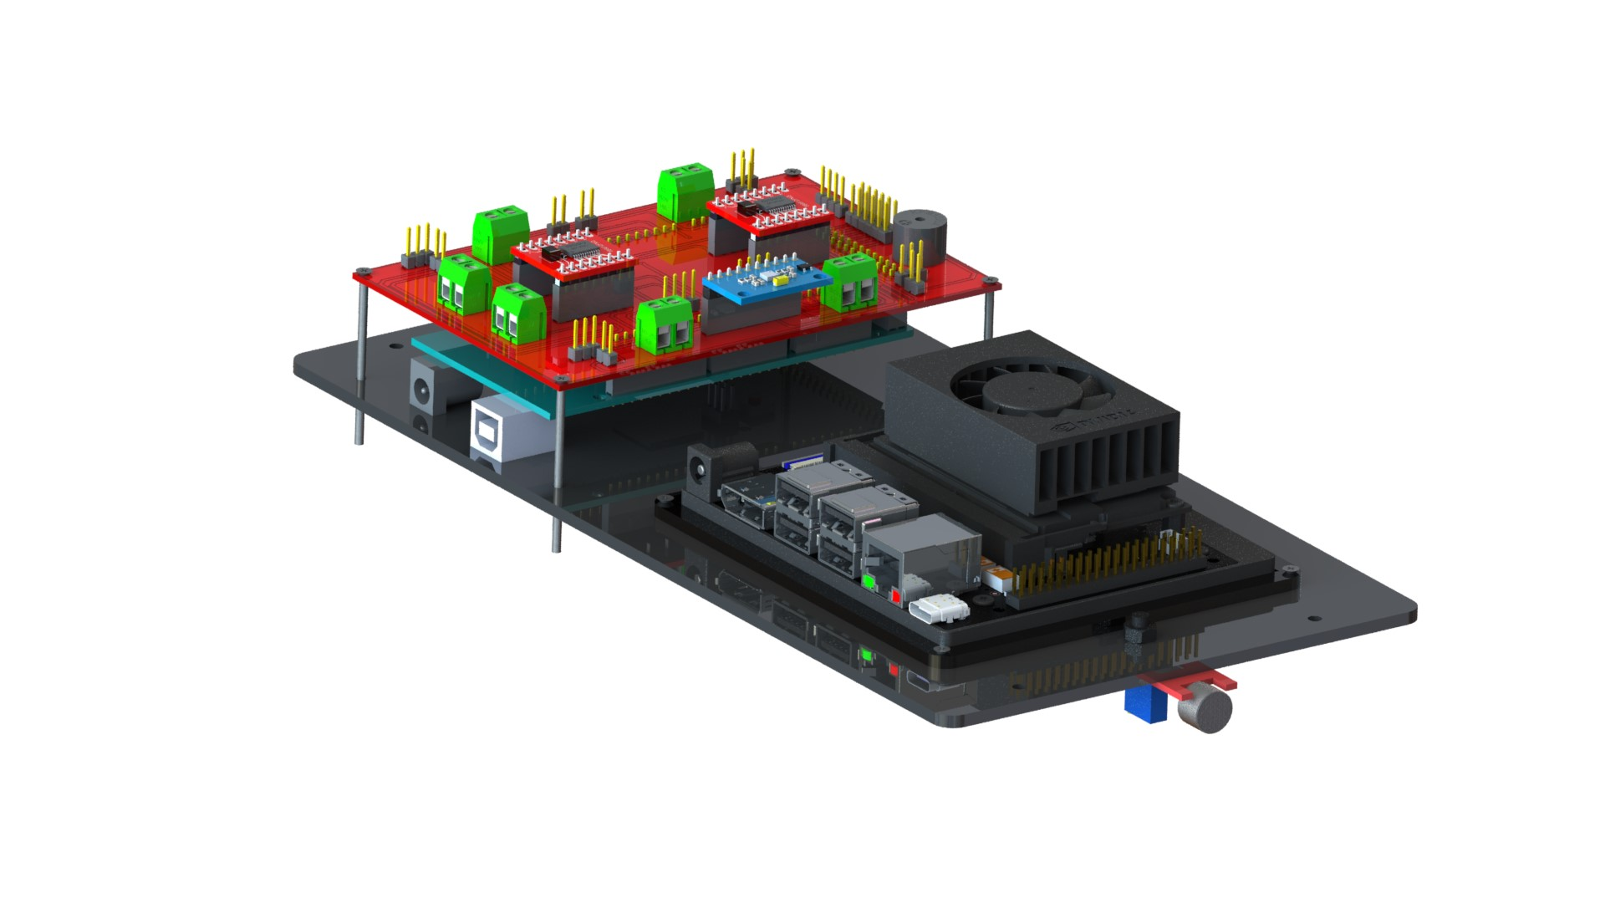

**Components:**

|  |  |  |
| --- | --- | --- |
| **Jetson Orin Nano (x1)** | **Auxiliary Board (x1)** |   **Sound Sensor (x1)** |
| **Platform 3 (x1)** |   **SBC Frame (x1)** | **M2 x 25 Bolt (x4)** |
| **M2 x 10 Bolt (x4)** | **M2 Nut (x8)** | **M4 Nut (x1)** |
| **M4 x 10 Bolt (x1)** |

**Overall Steps:**

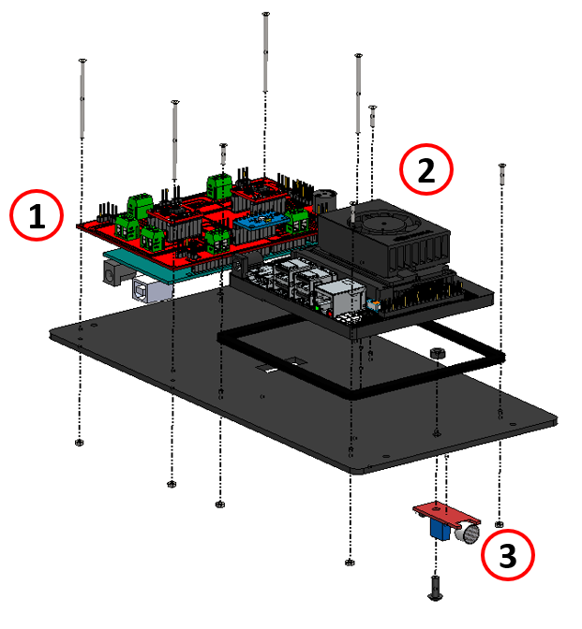

**Detailed Steps:**

1. Assemble the auxiliary board PCB based on the flowing schematic and layout.

|  |  |  |
| --- | --- | --- |
|  |  |  |
| [Breadboard View](https://github.com/AutoDRIVE-Ecosystem/Nigel-Fritzing/blob/pcb-v2.0.0/Breadboard.png) | [Schematic View](https://github.com/AutoDRIVE-Ecosystem/Nigel-Fritzing/blob/pcb-v2.0.0/Schematic.png) | [PCB View](https://github.com/AutoDRIVE-Ecosystem/Nigel-Fritzing/blob/pcb-v2.0.0/PCB.png) |

***Hint:*** *The hyperlinks will re-direct to high-resolution images for better clarity. Additionally, the open-source PCB designs are available* [*here*](https://github.com/AutoDRIVE-Ecosystem/Nigel-Fritzing/tree/pcb-v2.0.0)*.*

1. Assembly of the auxiliary board onto the platform.

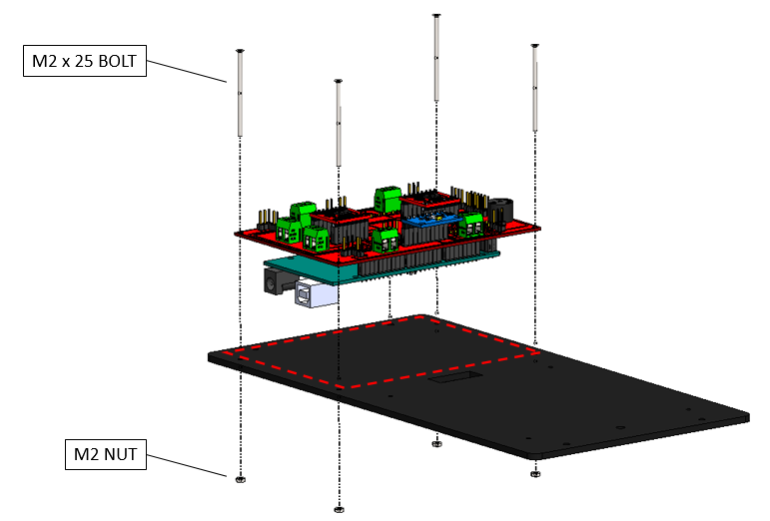

1. Assembly of the SBC frame onto the platform.

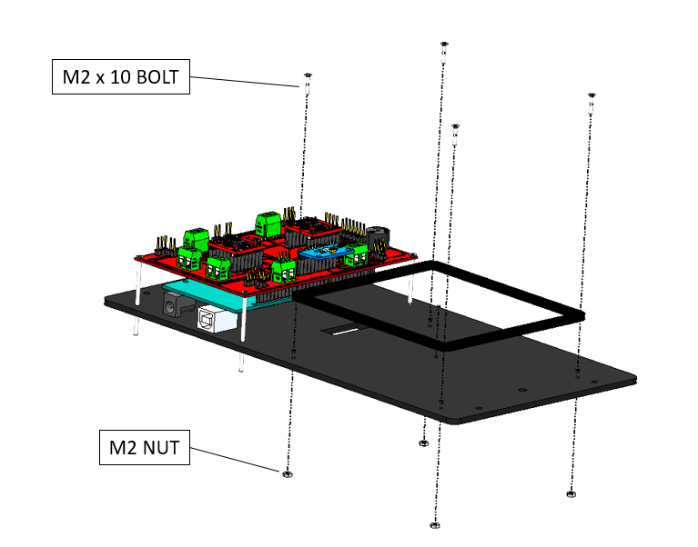

1. Press-fit the Jetson Orin Nano within the SBC frame.

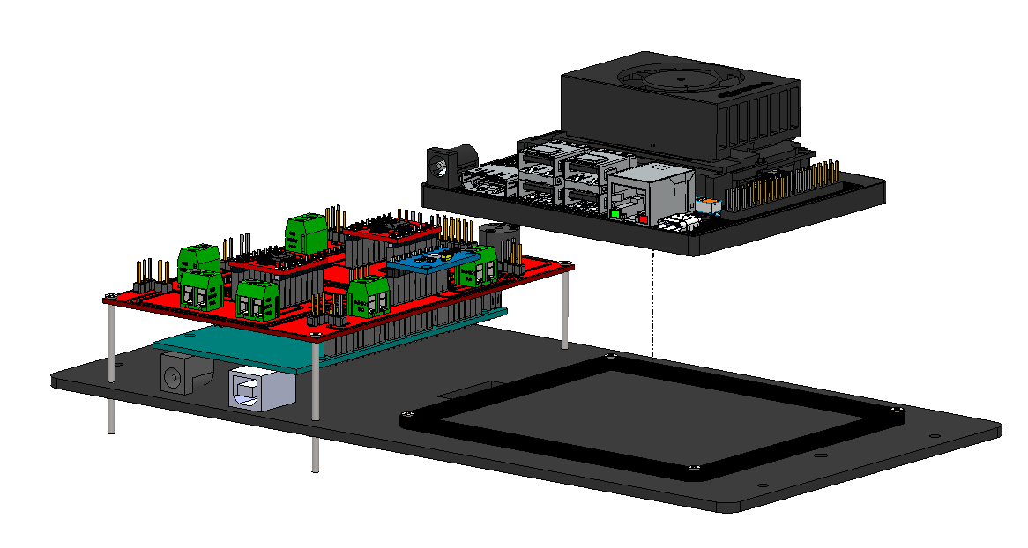

1. Assembly of the microphone onto the platform.

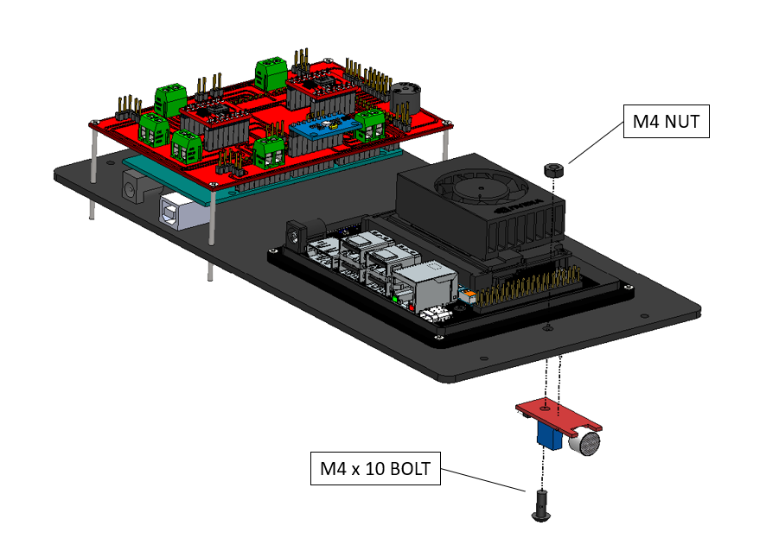

## **2.4 Platform 4 Assembly**

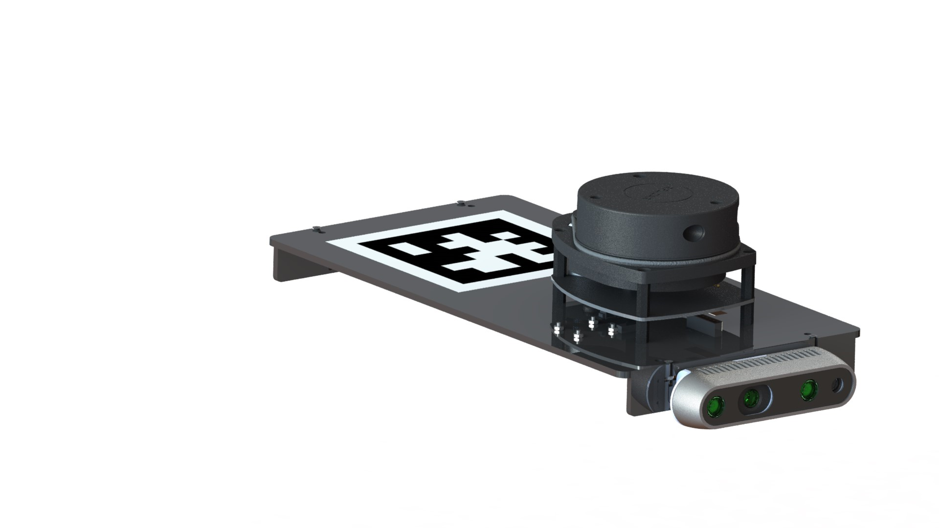

**Components:**

|  |  |  |
| --- | --- | --- |
| **RPLIDAR A1 (x1)** | **LIDAR Adapter (x1)** | **PiCam V2.1 (x1)** |
| **Intel RealSense D435i (x1)** | **Platform 4 (x1)** | **Camera Mount (x2)** |
| **AprilTag Marker (x1)** | **M2.5x8 Bolt (x4)** | **M2x10 Bolt (x12)** |
| **M3x6 Bolt (x2)** | **M2 Nut (x22)** |

**Overall Steps:**

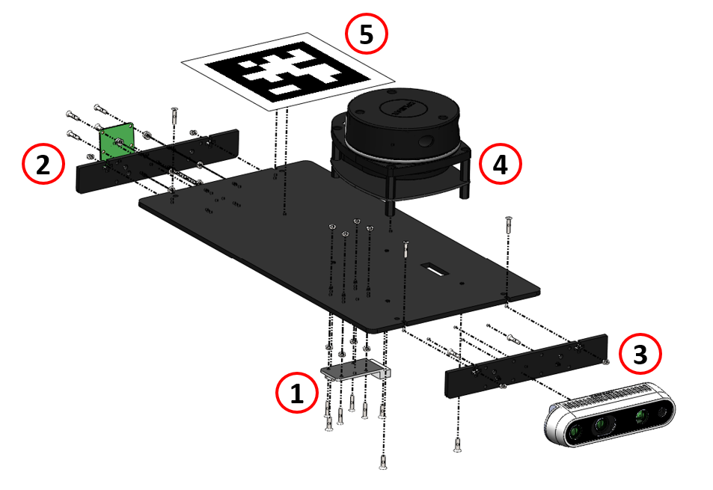

**Detailed Steps:**

1. Fitment of the LIDAR adapter onto the platform.

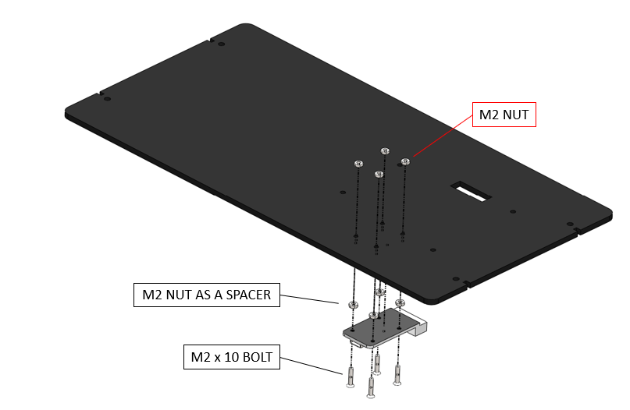

1. Assembly of the rear camera mount onto the platform.

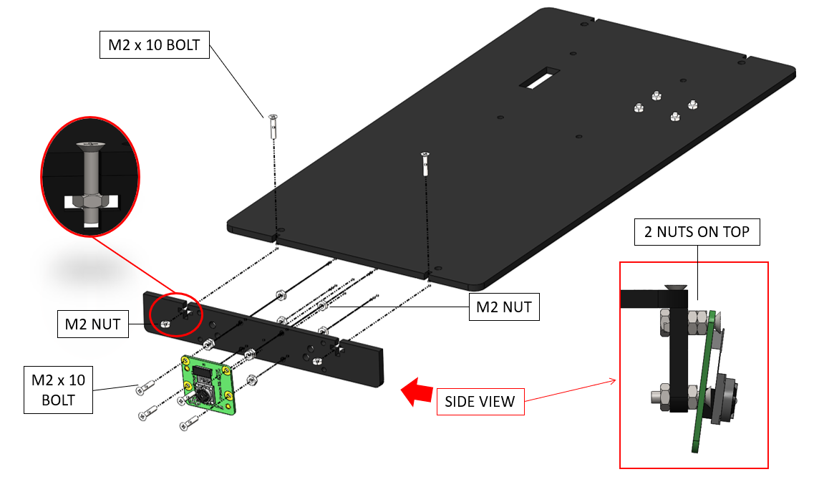

***Hint:*** *You may alter the tilting angle of the front/rear camera(s) by varying the number of spacer nuts in the top and bottom mounting holes.*

1. Assembly of the front camera mount onto the platform.

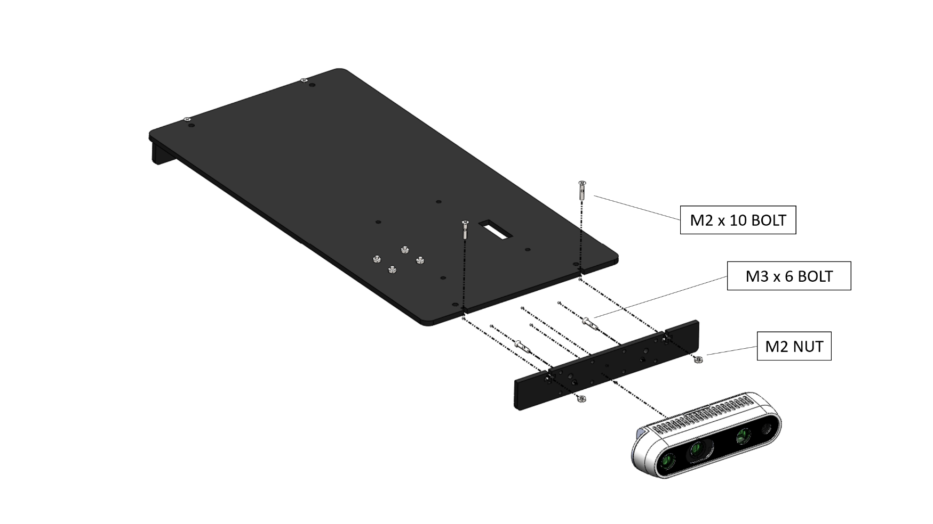

***Hint:*** *The modular holes in front/rear camera mounts enable several variations in front/rear camera setups. Additionally, you may edit the source files to adapt the mounting holes for any other camera module(s).*

|  |  |  |
| --- | --- | --- |
| **PI CAM v2.1** | **INTEL D435i** | **INTEL T265** |

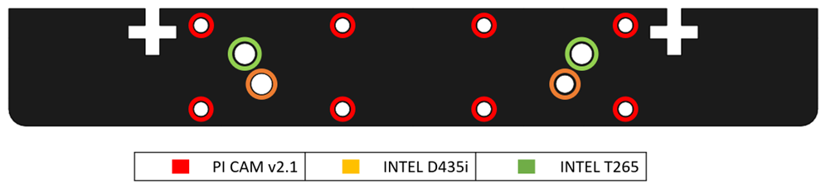

1. Assembly of the LIDAR onto the platform.

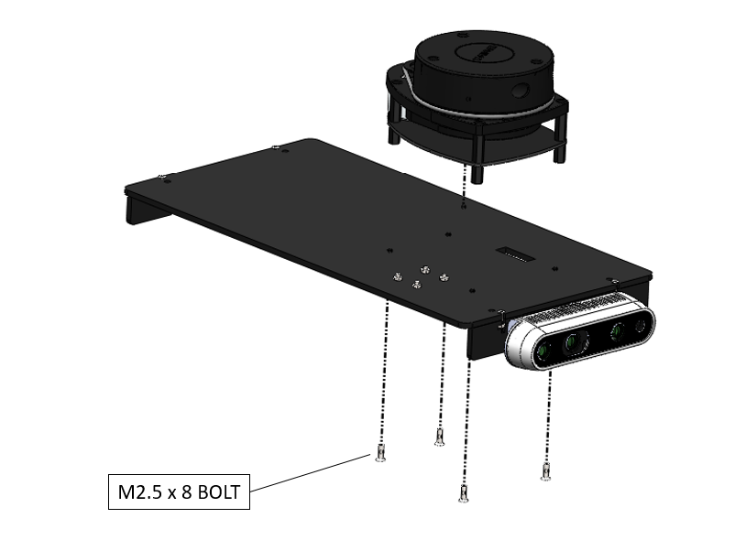

1. Assembly of the AprilTag marker onto the platform.

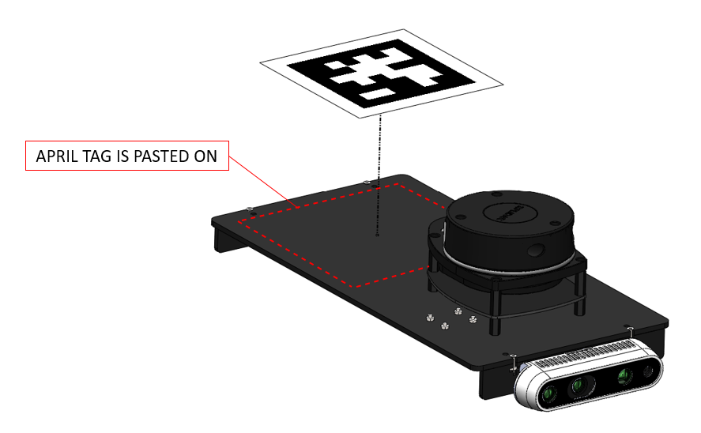

***Hint:*** *In a multi-agent setting, you can use distinct AprilTag markers on each vehicle to uniquely identify them.*

## **2.5 Overall Assembly**



**Components:**

|  |  |  |  |
| --- | --- | --- | --- |
|   **M3 x 60 MF Standoff (x4)** |   **M3 x 40 FF Standoff (x10)** | **M3 x 40 MF Standoff (x6)** |   **M3 x 8 Bolt (x20)** |
| **Platform 1 (x1)** |

**Overall Steps:**

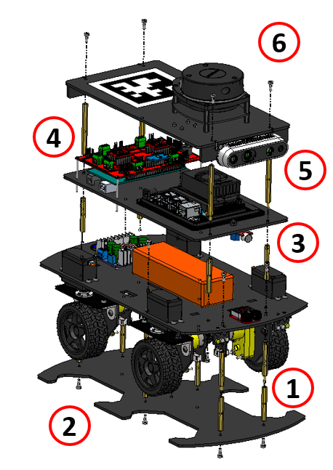

**Detailed Steps:**

1. Assembly of the lower standoffs on Platform 2.

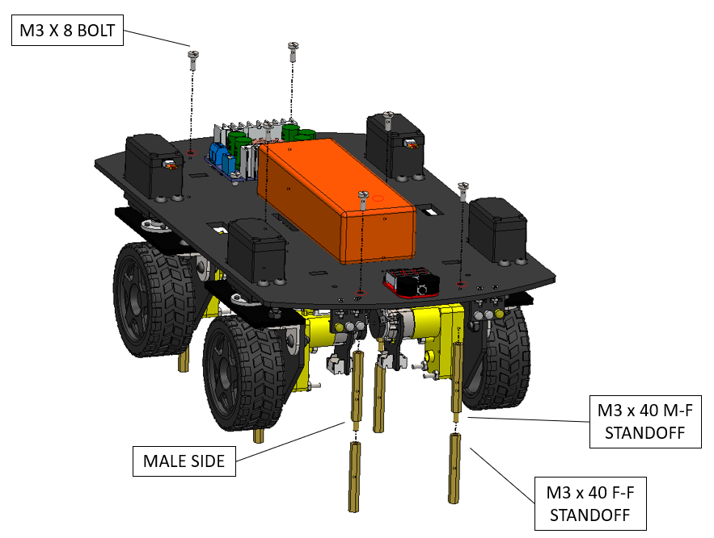

***Hint:*** *The length of standoffs attached between the first and second platforms decides the ground clearance of the vehicle. However, it also inversely affects the space available for the drive actuators and their respective cables to steer in place. Consequently, these standoffs should be chosen carefully to match this tradeoff.*

1. Securing Platform 1 on the lower standoffs of Platform 2.

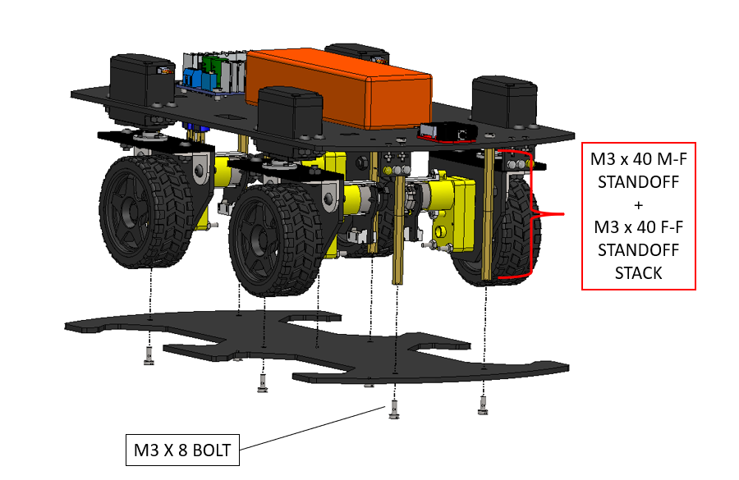

1. Assembly of the upper standoffs on Platform 2.

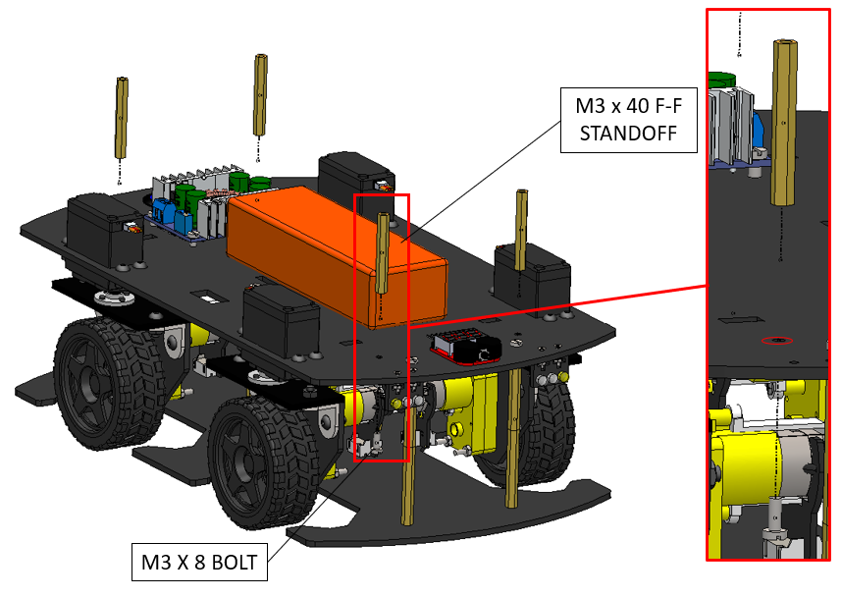

1. Securing Platform 3 on the upper standoffs of Platform 2.

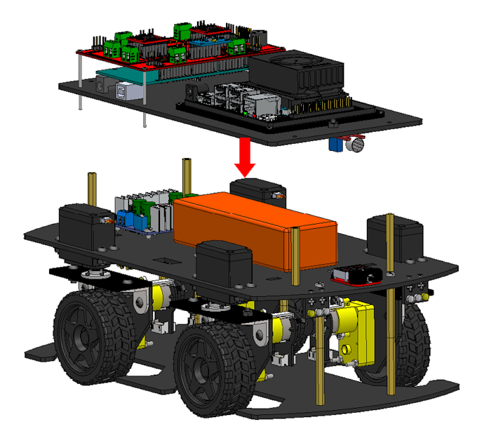

1. Assembly of standoffs on Platform 3.

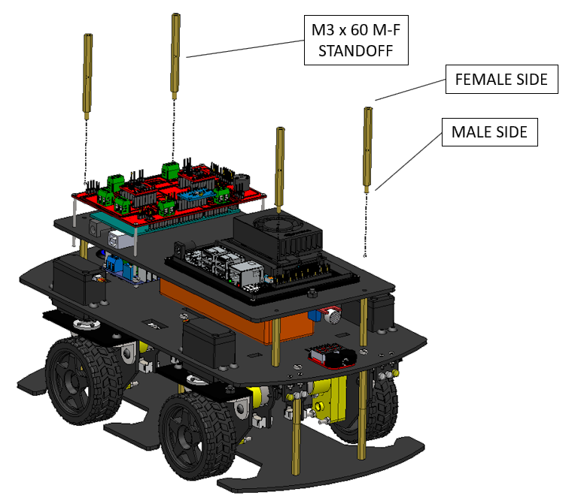

1. Securing Platform 4 on the standoffs of Platform 3.

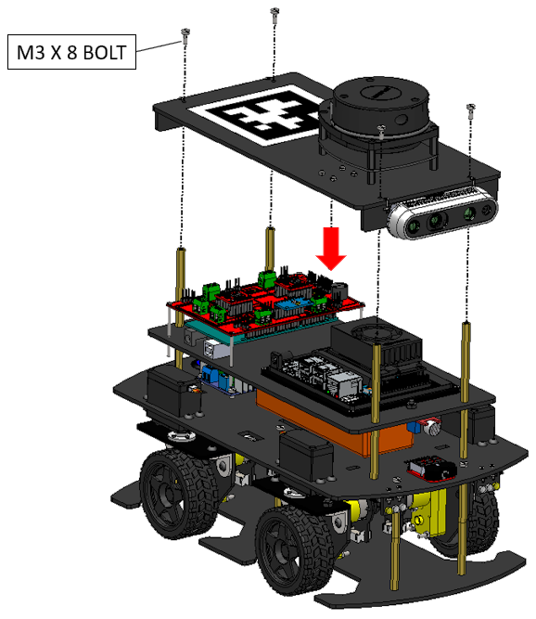

***Hint:*** *Congratulations! Your Nigel is ready for a test drive. Just flash the firmware and take it for a spin!*

# **3. Actuation Redundancy**

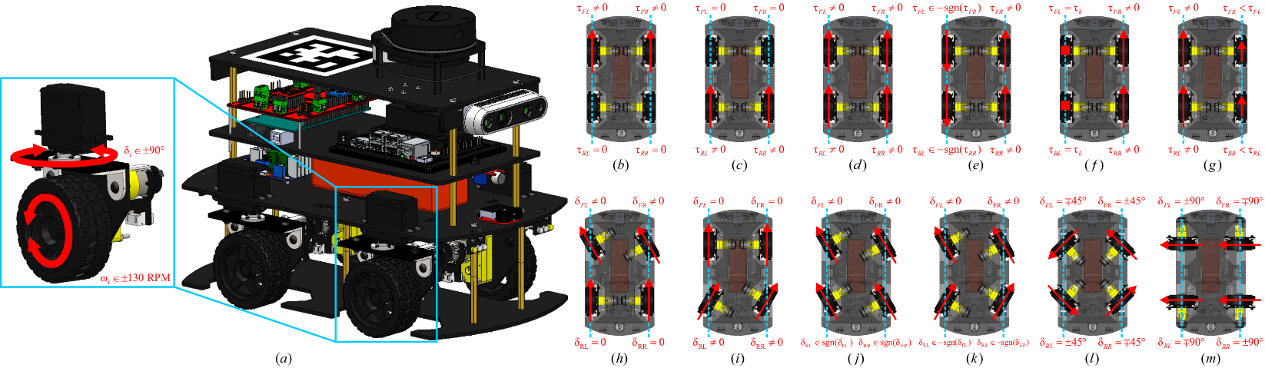

Nigel is a mechatronically redundant autonomous vehicle platform offering comprehensive autonomy features as well as independent all-wheel driving and independent all-wheel steering (i.e., independent 4WD4WS) configuration, with extended ($±$ 90 $°$) steering angles. Particularly, the independent 4WD4WS architecture of Nigel offers 2-DOF actuation redundancy per wheel. This allows the vehicle to switch between a wide array of driving and steering configurations.

Common drive configurations:

* **Front-wheel drive:** Provides active traction to front wheels (e.g. commercial cars)
* **Rear-wheel drive:** Provides active traction to rear wheels (e.g. performance cars)
* **All-wheel drive:** Provides active traction to all wheels (e.g. all-terrain vehicles)
* **Neutral-steer drive:** Provides opposite traction to left and right wheels (e.g. tanks)
* **Pivot-steer drive:** Provides active traction only to left or right wheels (e.g. tanks)
* **Torque vectoring drive:** Splits traction to left and right wheels (e.g. AWD vehicles)

Common steering configurations:

* **Front-wheel steer:** Conventional (e.g. car-like) driving maneuvers
* **Rear-wheel steer:** Specialized (e.g. forklifts) driving maneuvers
* **All-wheel in-phase steer:** Enhanced steerability at high speeds (e.g. highway lane change)
* **All-wheel out-of-phase steer:** Enhanced steerability at low speeds (e.g. parking lots)
* **Oblique steer:** For on-the-spot turns without skidding (e.g. turning in tight spaces)
* **Crab-walk steer:** 90 $°$ parallel steering for lateral movement (e.g. parallel parking)

The possibility to control the torque/velocity and steering/direction of each wheel independently allows the implementation of complex control strategies for autonomy in different environments and maneuvers. Active steering control, torque vectoring, robust control and fault-tolerant control strategies are some examples.

# **4. Modularity and Reconfigurability**

AutoDRIVE Ecosystem fosters mechatronics design principles at two levels of design reconﬁgurability, thereby promoting hardware-software co-design.

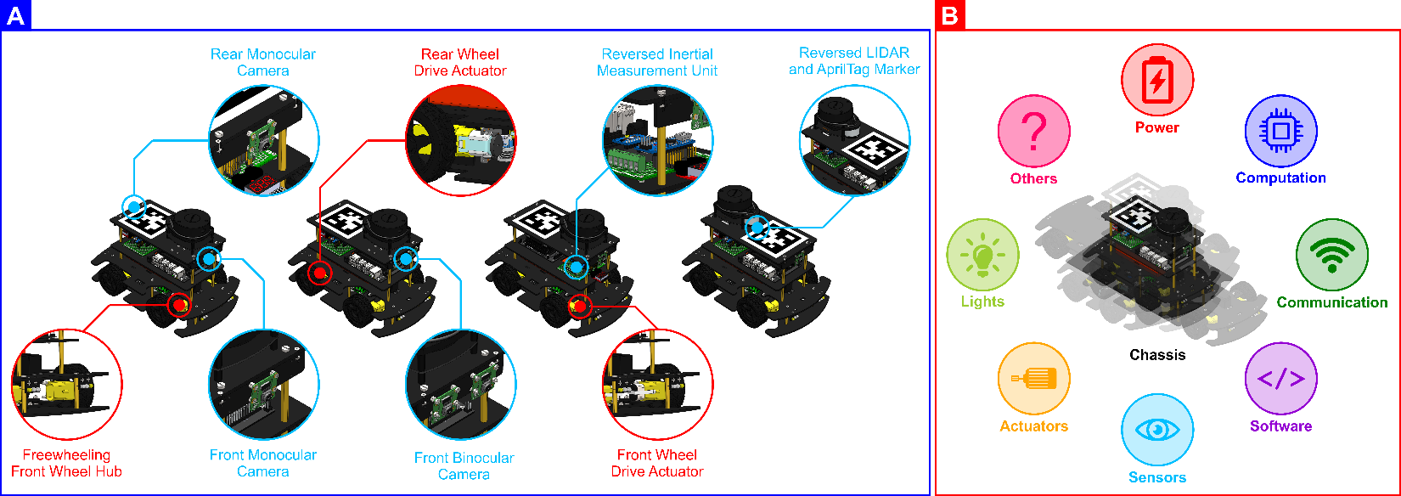

**[A] Primitive Reconﬁgurability:** Nigel is modular enough to support out-of-the-box hardware reconﬁgurability in terms of adding, removing or replacing selective components and sub-assemblies of the vehicle for perception (encoders, microphone, IPS, IMU, cameras, LIDAR, etc.), computation (high/low-level), communication (wired/wireless), actuation (driving/steering configurations), signaling (head/tail-lights, turn/reverse indicators, buzzer) and power (battery, power electronics) in addition to ﬂexibly updating the vehicle ﬁrmware and/or autonomous driving software stack (ADSS) to better suit target application(s).

**[B] Advanced Reconﬁgurability:** The completely open-hardware, open-software architecture of AutoDRIVE Ecosystem allows complete modiﬁcation of vehicle chassis parameters (different form factors and component mounting proﬁles), powertrain conﬁguration (variable driving/steering performance), as well as ﬁrmware and ADSS architecture (software ﬂexibility), and also provides an opportunity for introducing new features and functionalities to the ecosystem.

# **5. Supplemental Material**



AutoDRIVE Ecosystem is completely open-source, with all the hardware and software source files available publicly. The following resources will come in handy as you get started with AutoDRIVE:

|  |  |
| --- | --- |
|  | <https://autodrive-ecosystem.github.io> |
|  | <https://www.youtube.com/@AutoDRIVE-Ecosystem> |
|  | <https://github.com/AutoDRIVE-Ecosystem> |
|  | <https://doi.org/10.3390/robotics12030077> |

Particularly, the source files for [mechanical](https://github.com/Tinker-Twins/AutoDRIVE/tree/AutoDRIVE-Testbed/Vehicle/Nigel%204WD4WS/Mechanical/Manufacturing/Laser%20Cutting), [electrical](https://github.com/Tinker-Twins/AutoDRIVE/tree/AutoDRIVE-Testbed/Vehicle/Nigel%204WD4WS/Electrical) and [software](https://github.com/Tinker-Twins/AutoDRIVE/tree/AutoDRIVE-Testbed/Vehicle/Nigel%204WD4WS/Software) components and sub-systems of the Nigel are available on GitHub. Additionally, you can also find the source files for [AutoDRIVE Testbed](https://github.com/Tinker-Twins/AutoDRIVE/tree/AutoDRIVE-Testbed), [AutoDRIVE Simulator](https://github.com/Tinker-Twins/AutoDRIVE/tree/AutoDRIVE-Simulator) and [AutoDRIVE Devkit](https://github.com/Tinker-Twins/AutoDRIVE/tree/AutoDRIVE-Devkit), which together make up the AutoDRIVE Ecosystem.